HOSE-Index Series |  |  | Data as at: 31 May 2019
HOSE-Index is a market-capitalization weighted investable index series comprised of companies listed on the Hochiminh Stock Exchange (HOSE). The constituents are screened for eligibility, free-float and liquidity. HOSE-Index Series covers over 90% total traded value and 80% HOSE’s market capitalization.
HOSE-Index Structure |  |  | Features
VNAllshare is a market-capitalization weighted index comprises all HOSE-listed companies that passed screening for eligibility, free-float and liquidity.  VN30 is a market-capitalization weighted index which measures the performance of 30 large market-capitalization and high liquidity stocks from VNAllshare.  VNMidcap is a market-capitalization weighted index which measures the performance of 70 medium market-capitalization companies from VNAllshare.  VN100 is a market-capitalization weighted index combining constituents from both VN30 and VNMidcap.  VNSmallcap is a market-capitalization weighted index and designed to measure the performance of small market-capitalization companies from VNAllshare.  VNAllshare Sector Indices is a series of sector index comprised of constituents from VNAllshare classified according to the Global Industry Classification Standard (GICS®). |  |  | Objective  The indices are designed for use in the creation of index track funds, derivatives and as a performance benchmark.  Investability  Stocks are selected and calculated by free-float to ensure index is investable.  Liquidity  Stocks are screened to ensure index is tradable.  Transparency  The indices use a transparent, rules-based construction process. Index Rules are freely available on the HOSE website.  Availability  The indices are calculated in real-time or end of day.  Review Dates  Semi-annually in January and July.  Capping Limit  10%(Not applied for VNAllshare Sector)  Index Methodology  Free-floatadjusted market-capitalization weighted index.  Industry Classification Benchmark  Index constituents are classified in accordance with the Global Industry Classification Standard (GICS®).
Indices Performance
 | Performance (%) |  |  |  |  |  |  |  |  | Annualized Performance (%)
 | 2016 | 2017 | 2018 | 1 month | 3 months | 6 months | 1 year | 3 years | 5 years | 3 years | 5 years
VNAllShare | 7.46% | 48.27% | -12.02% | -1.80% | -2.97% | -0.10% | -4.99% | 39.35% | 54.08% | 11.70% | 9.03%
VN30 | 5.48% | 53.89% | -12.36% | -1.60% | -3.17% | -2.07% | -7.50% | 41.90% | 41.79% | 12.37% | 7.23%
VNMidcap | 8.24% | 32.38% | -12.78% | -1.21% | -3.84% | 2.18% | -2.50% | 22.54% | 71.00% | 7.01% | 11.33%
VN100 | 7.00% | 50.21% | -11.68% | -1.86% | -3.23% | -0.28% | -5.30% | 41.82% | 54.55% | 12.35% | 9.10%
VNSmallcap | 8.94% | 22.54% | -15.81% | -1.41% | 2.92% | 1.33% | -2.01% | 6.89% | 41.05% | 2.25% | 7.12%
VN Index | 14.82% | 46.46% | -9.32% | -2.02% | -0.58% | 3.60% | -1.17% | 55.21% | 70.79% | 15.78% | 11.30%

Indices Volatility | Correlation of Indices with VN Index
3 months 6 months 1 year 3 years 5 years  VNAllShare 6.27% 8.94% 16.37% 26.16% 32.71%  VN30 6.31% 9.36% 17.50% 28.74% 35.92%  VNMidcap 5.94% 8.74% 16.74% 25.97% 32.29%  VN100 6.41% 9.16% 16.86% 26.96% 33.61%  VNSmallcap 4.54% 6.08% 10.38% 19.33% 27.45%  VN Index 6.48% 9.01% 16.51% 27.56% 35.77% | 3 months 6 months 1 year 3 years 5 years  VNAllShare 97.73% 97.53% 97.68% 95.84% 94.51%  VN30 95.65% 95.34% 96.84% 95.55% 94.41%  VNMidcap 87.26% 78.70% 86.02% 78.81% 78.50%  VN100 97.70% 97.50% 97.66% 95.94% 94.63%  VNSmallcap 72.13% 69.00% 79.02% 69.16% 69.26%
Indices Characteristics
 | VNAllshare | VN30 | VNMidcap | VN100 | VNSmallcap
Number of Constituents | 249 | 30 | 70 | 100 | 149
Full Market-Capitalization (Billion VND) | 2,735,831 | 2,350,098 | 295,667 | 2,645,765 | 90,066
Free-float adjusted Market-Capitalization (Billion VND) | 979,522 | 790,328 | 144,440 | 934,768 | 44,754
Average | 3,934 | 26,344 | 2,063 | 9,348 | 300
Max | 112,756 | 112,756 | 11,181 | 112,756 | 1,835
Min | 15 | 2,794 | 204 | 204 | 15
Median | 436 | 19,219 | 1,701 | 2,359 | 233
Weighted capitalization of largest company | 11.51% | 14.27% | 7.74% | 12.06% | 4.10%
Weighted capitalization of top-10 companies | 56.28% | 69.75% | 38.93% | 58.97% | 22.45%

Disclaimer: "VN30", "VNMidcap", "VNSmallCap", “VN100”, “VNAllshare” and "VNAllshare Sector" (collectively called "HOSE-Index") are the registered trademarks and/or service mark solely owned by, and proprietary to the Hochiminh Stock Exchange (HOSE). HOSE-Index can be used to create a range of index-linked products including but not limited to tracker funds, derivatives, etc. Such product creation is subject to approval by HOSE. For more information, please contact via e-mail: index@hsx.vn
All information is provided for information purposes only. Every effort is made to ensure that all information given in this publication is accurate, but no responsibility or liability can be accepted by HOSE nor its directors, officers, employees, partners or licensors for any errors or for any loss from use of this publication or any of the information or data contained herein.

VNAllshare Index |  |  |  |  |  | Data as at: 31 May 2019
VNAllshare is a market-capitalization weighted index comprises all HOSE-listed companies that passed screening for eligibility, free-float and liquidity.
Index Characteristics |  |  |  | Information
Number of Constituents 249 252 252 243 228 234 222 223 242 242  Full Market-Capitalization (Billion VND) 2,735,831 2,792,228 2,754,723 2,266,516 1,294,798 1,308,015 1,298,572 1,255,370 1,043,110 1,043,109,667,139  Free-float adjusted Market-Capitalization (Billion VND) 979,522 1,011,020 1,023,479 736,629 464,807 461,643 463,177 446,893 414,596 414,596,030,693  Average 3,934 4,012 4,061 3,031 2,039 1,973 2,086 2,004 1,713 1,713,206,738  Max 112,756 113,017 122,856 119,149 96,664 93,595 101,848 85,330 76,149 76,148,844,803  Min 15 19 16 19 13 14 18 21 16 15,592,500  Median 436 457 461 408 424 411 424 448 375 375,021,338  Weighted capitalization of largest company 11.51% 11.18% 12.00% 16.17% 20.80% 20.27% 21.99% 19.09% 18.37% 18.37%  Weighted capitalization of top-10 companies 56.28% 56.37% 56.94% 60.22% 55.41% 55.31% 57.49% 56.05% 54.92% 54.92% |  |  |  | Base Date: 24/01/2014  Base Value: 560.19  Availability: Price and Total Return  Frequency:  - VNAllshare: Once per minute.  - VNAllshareTRI: End of day.  Capping limit: 10%  Calculation Method: Free-float adjusted market-capitalization weighted index.  Currency: VND
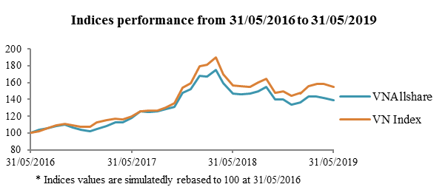 |  |  |  | Index Volatility
 | 3 months | 6 months | 1 year | 3 years | 5 years
VNAllshare | 6.27% | 8.94% | 16.37% | 26.16% | 32.71%

 |  |  |  | Correlation with VN Index
 | 3 months | 6 months | 1 year | 3 years | 5 years
VNAllshare | 97.73% | 97.53% | 97.68% | 95.84% | 94.51%

Index Performance
 | Performance (%) |  |  |  |  |  |  |  |  | Annualized Performance (%)
 | 2016 | 2017 | 2018 | 1 month | 3 months | 6 months | 1 year | 3 years | 5 years | 3 years | 5 years
VNAllshare | 7.46% | 48.27% | -12.02% | -1.80% | -2.97% | -0.10% | -4.99% | 39.35% | 54.08% | 11.70% | 9.03%

Sector Breakdown | Top-10 Constituents of Market Capitalization
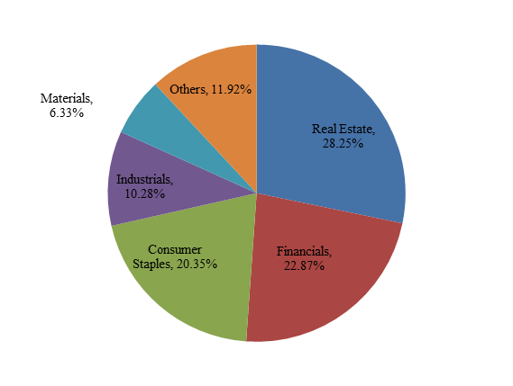 | Stock Sector Free-float adjusted market-cap (Billion VND) Weight (%)  1 VNM Consumer Staples 112,756 11.51%  2 VIC Real Estate 109,728 11.20%  3 VHM Real Estate 68,665 7.01%  4 TCB Financials 51,365 5.24%  5 HPG Materials 40,906 4.18%  6 MSN Consumer Staples 39,919 4.08%  7 VRE Real Estate 36,469 3.72%  8 VJC Industrials 33,715 3.44%  9 VPB Financials 31,299 3.20%  10 MBB Financials 26,439 2.70%  Total 551,262 56.28%  Disclaimer: "VN30", "VNMidcap", "VNSmallCap", “VN100”, “VNAllshare” and "VNAllshare Sector" (collectively called "HOSE-Index") are the registered trademarks and/or service mark solely owned by, and proprietary to the Hochiminh Stock Exchange (HOSE). HOSE-Index can be used to create a range of index-linked products including but not limited to tracker funds, derivatives, etc. Such product creation is subject to approval by HOSE. For more information, please contact via e-mail: index@hsx.vn  All information is provided for information purposes only. Every effort is made to ensure that all information given in this publication is accurate, but no responsibility or liability can be accepted by HOSE nor its directors, officers, employees, partners or licensors for any errors or for any loss from use of this publication or any of the information or data contained herein.
Top-5 Sectors of Market Capitalization
Sector | Number of Companies | Free-float adjusted  market-cap (Billion VND) | Weight  (%)
Real Estate | 35 | 276,716 | 28.25%
Financials | 24 | 223,996 | 22.87%
Consumer Staples | 24 | 199,322 | 20.35%
Industrials | 64 | 100,732 | 10.28%
Materials | 37 | 62,013 | 6.33%

VN30 Index |  |  |  |  |  | Data as at: 31 May 2019
VN30 is a market-capitalization weighted index which measures the performance of 30 large cap and high liquidity stocks from VNAllshare.
Index Characteristics |  |  |  |  | Information
Number of Constituents 30 30 30 30 30 30 30 30 30  Full Market-Capitalization (Billion VND) 2,350,098 2,399,314 2,362,794 2,143,718 1,042,343 1,045,617 997,461 774,158 774,158,368,759  Free-float adjusted Market-Capitalization (Billion VND) 790,328 818,966 830,531 631,627 345,174 341,030 321,981 292,670 292,669,863,151  Average 26,344 27,299 27,684 21,054 11,506 11,368 10,733 9,756 9,755,662,105  Max 112,756 113,017 122,856 134,242 96,664 101,848 85,330 76,149 76,148,844,803  Min 2,794 2,818 3,193 2,182 1,494 1,201 1,225 1,145 1,145,356,610  Median 19,219 19,886 20,470 10,420 5,271 4,721 4,513 4,175 4,175,382,531  Weighted capitalization of largest company 14.27% 13.80% 14.79% 21.25% 28.00% 29.86% 26.50% 26.02% 26.02%  Weighted capitalization of top-10 companies 69.75% 69.59% 70.17% 76.25% 74.62% 77.83% 77.13% 77.80% 77.80% |  |  |  | Base Date: 02/01/2009  Base Value: 313.34  Availability: Price and Total Return  Frequency:  - VN30: Once per minute.  - VN30TRI: End of day.  Capping limit: 10%  Calculation Method: Free-float adjusted market-capitalization weighted index.  Currency: VND
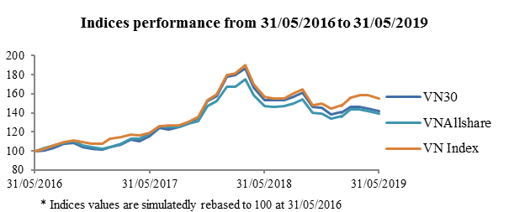 |  |  |  | Index Volatility
 | 3 months | 6 months | 1 year | 3 years | 5 years
VN30 | 6.31% | 9.36% | 17.50% | 28.74% | 35.92%

 |  |  |  | Correlation with VN Index
 | 3 months | 6 months | 1 year | 3 years | 5 years
VN30 | 95.65% | 95.34% | 96.84% | 95.55% | 94.41%

Index Performance
 | Performance (%) |  |  |  |  |  |  |  |  | Annualized Performance (%)
 | 2016 | 2017 | 2018 | 1 month | 3 months | 6 months | 1 year | 3 years | 5 years | 3 years | 5 years
VN30 | 5.48% | 53.89% | -12.36% | -1.60% | -3.17% | -2.07% | -7.50% | 41.90% | 41.79% | 12.37% | 7.23%

Sector Breakdown |  | Top-10 Constituents of Market Capitalization
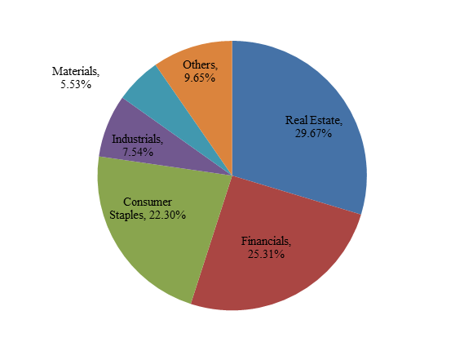 |  | Stock Sector Free-float adjusted market-cap (Billion VND) Weight (%)  1 VNM Consumer Staples 112,756 14.27%  2 VIC Real Estate 109,728 13.88%  3 VHM Real Estate 68,665 8.69%  4 TCB Financials 51,365 6.50%  5 HPG Materials 40,906 5.18%  6 MSN Consumer Staples 39,919 5.05%  7 VRE Real Estate 36,469 4.61%  8 VJC Industrials 33,715 4.27%  9 VPB Financials 31,299 3.96%  10 MBB Financials 26,439 3.35%  Total 551,262 69.75%  Disclaimer: "VN30", "VNMidcap", "VNSmallCap", “VN100”, “VNAllshare” and "VNAllshare Sector" (collectively called "HOSE-Index") are the registered trademarks and/or service mark solely owned by, and proprietary to the Hochiminh Stock Exchange (HOSE). HOSE-Index can be used to create a range of index-linked products including but not limited to tracker funds, derivatives, etc. Such product creation is subject to approval by HOSE. For more information, please contact via e-mail: index@hsx.vn  All information is provided for information purposes only. Every effort is made to ensure that all information given in this publication is accurate, but no responsibility or liability can be accepted by HOSE nor its directors, officers, employees, partners or licensors for any errors or for any loss from use of this publication or any of the information or data contained herein.
Top-5 Sectors of Market Capitalization
Sector | Number of Companies | Free-float adjusted  market-cap (Billion VND) | Weight  (%)
Real Estate | 4 | 234,467 | 29.67%
Financials | 9 | 200,057 | 25.31%
Consumer Staples | 4 | 176,249 | 22.30%
Industrials | 6 | 59,604 | 7.54%
Materials | 2 | 43,701 | 5.53%

VNMidcap Index |  |  | Data as at: 31 May 2019
VNMidcap is a market-capitalization weighted index which measures the performance of 70 medium market-capitalization companies from VNAllshare.
Index Characteristics |  |  |  |  | Information
Number of Constituents 70 70 70 70 70 70 70 70 70  Full Market-Capitalization (Billion VND) 295,667 299,624 304,034 257,279 190,984 192,812 195,768 199,752 199,751,840,333  Free-float adjusted Market-Capitalization (Billion VND) 144,440 145,671 149,088 131,276 88,581 90,949 92,238 86,595 86,594,628,464  Average 2,063 2,081 2,130 1,875 1,265 1,299 1,318 1,237 1,237,066,121  Max 11,181 9,988 9,707 12,940 6,479 10,327 10,973 7,216 7,216,178,809  Min 204 246 237 259 76 121 129 148 147,839,967  Median 1,701 1,667 1,728 1,180 842 897 1,011 871 871,064,160  Weighted capitalization of largest company 7.74% 6.86% 6.51% 9.86% 7.31% 11.36% 11.90% 8.33% 8.33%  Weighted capitalization of top-10 companies 38.93% 38.29% 38.70% 43.95% 37.86% 43.42% 42.19% 43.07% 43.07% |  |  |  | Base Date: 24/01/2014  Base Value: 560.19  Availability: Price and Total Return  Frequency:  - VNMidcap: Once per minute.  - VNMidcapTRI: End of day.  Capping limit: 10%  Calculation Method: Free-float adjusted market-capitalization weighted index.  Currency: VND
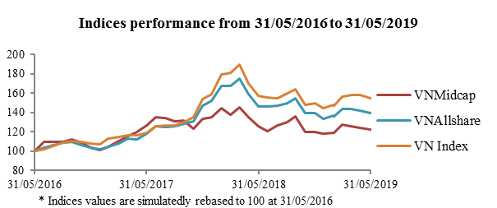 |  |  |  | Index Volatility
 | 3 months | 6 months | 1 year | 3 years | 5 years
VNMidcap | 5.94% | 8.74% | 16.74% | 25.97% | 32.29%

 |  |  |  | Correlation with VN Index
 | 3 months | 6 months | 1 year | 3 years | 5 years
VNMidcap | 87.26% | 78.70% | 86.02% | 78.81% | 78.50%

Index Performance
 | Performance (%) |  |  |  |  |  |  |  |  | Annualized Performance (%)
 | 2016 | 2017 | 2018 | 1 month | 3 months | 6 months | 1 year | 3 years | 5 years | 3 years | 5 years
VNMid | 8.24% | 32.38% | -12.78% | -1.21% | -3.84% | 2.18% | -2.50% | 22.54% | 71.00% | 7.01% | 11.33%

Sector Breakdown |  | Top-10 Constituents of Market Capitalization
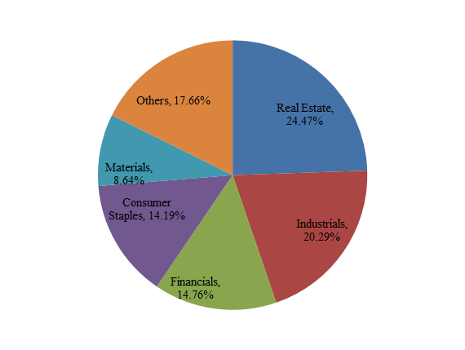 |  | Stock Sector Free-float adjusted market-cap (Billion VND) Weight (%)  1 TPB Financials 11,181 7.74%  2 KDH Real Estate 7,701 5.33%  3 GEX Industrials 6,815 4.72%  4 HNG Consumer Staples 5,392 3.73%  5 KBC Real Estate 5,073 3.51%  6 DXG Real Estate 4,801 3.32%  7 TCH Industrials 4,022 2.78%  8 NLG Real Estate 3,887 2.69%  9 VHC Consumer Staples 3,784 2.62%  10 PVD Energy 3,580 2.48%  Total 56,235 38.93%  Disclaimer: "VN30", "VNMidcap", "VNSmallCap", “VN100”, “VNAllshare” and "VNAllshare Sector" (collectively called "HOSE-Index") are the registered trademarks and/or service mark solely owned by, and proprietary to the Hochiminh Stock Exchange (HOSE). HOSE-Index can be used to create a range of index-linked products including but not limited to tracker funds, derivatives, etc. Such product creation is subject to approval by HOSE. For more information, please contact via e-mail: index@hsx.vn  All information is provided for information purposes only. Every effort is made to ensure that all information given in this publication is accurate, but no responsibility or liability can be accepted by HOSE nor its directors, officers, employees, partners or licensors for any errors or for any loss from use of this publication or any of the information or data contained herein.
Top-5 Sectors of Market Capitalization
Sector | Number of Companies | Free-float adjusted  market-cap (Billion VND) | Weight  (%)
Real Estate | 13 | 35,338 | 24.47%
Industrials | 13 | 29,308 | 20.29%
Financials | 7 | 21,319 | 14.76%
Consumer Staples | 8 | 20,495 | 14.19%
Materials | 12 | 12,477 | 8.64%

VN100 Index |  |  |  |  | Data as at: 31 May 2019
 | VN100 is a market-capitalization weighted index combining constituents from both VN30 and VNMidcap.
 | Index Characteristics |  |  | Information
 | Number of Constituents 100 100 100 100 100 100 100 100 100  Full Market-Capitalization (Billion VND) 2,645,765 2,698,938 2,666,828 2,400,997 1,233,326 1,238,429 1,193,229 973,910 973,910,209,092  Free-float adjusted Market-Capitalization (Billion VND) 934,768 964,638 979,619 762,903 433,755 431,978 414,219 379,264 379,264,491,615  Average 9,348 9,646 9,796 7,629 4,338 4,320 4,142 3,793 3,792,644,916  Max 112,756 113,017 122,856 134,242 96,664 101,848 85,330 76,149 76,148,844,803  Min 204 246 237 259 76 121 129 148 147,839,967  Median 2,359 2,409 2,396 1,986 1,462 1,270 1,295 1,166 1,166,430,639  Weighted capitalization of largest company 12.06% 11.72% 12.54% 17.60% 22.29% 23.58% 20.60% 20.08% 20.08%  Weighted capitalization of top-10 companies 58.97% 59.08% 59.49% 63.13% 59.38% 61.64% 60.47% 60.03% 60.03% |  | Base Date: 24/01/2014  Base Value: 560.19  Availability: Price and Total Return  Frequency:  - VN100: Once per minute.  - VN100TRI: End of day.  Capping limit: 10%  Calculation Method: Free-float adjusted market-capitalization weighted index.  Currency: VND
 | 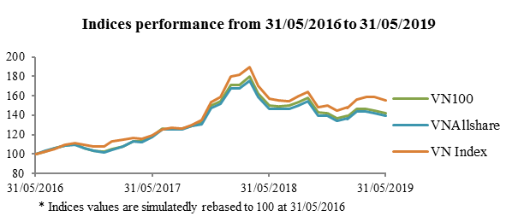 |  | Index Volatility
 | 3 months | 6 months | 1 year | 3 years | 5 years
VN100 | 6.41% | 9.16% | 16.86% | 26.96% | 33.61%

 |  |  | Correlation with VN Index
 | 3 months | 6 months | 1 year | 3 years | 5 years
VN100 | 97.70% | 97.50% | 97.66% | 95.94% | 94.63%

 | Index Performance
 | Performance (%) |  |  |  |  |  |  |  |  | Annualized Performance (%)
 | 2016 | 2017 | 2018 | 1 month | 3 months | 6 months | 1 year | 3 years | 5 years | 3 years | 5 years
VN100 | 7.00% | 50.21% | -11.68% | -1.86% | -3.23% | -0.28% | -5.30% | 41.82% | 54.55% | 12.35% | 9.10%

 | Sector Breakdown | Top-10 Constituents of Market Capitalization
 | 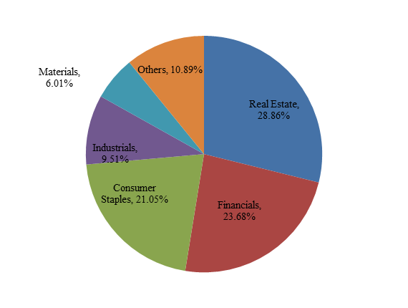 | Stock Sector Free-float adjusted market-cap (Billion VND) Weight (%)  1 VNM Consumer Staples 112,756 12.06%  2 VIC Real Estate 109,728 11.74%  3 VHM Real Estate 68,665 7.35%  4 TCB Financials 51,365 5.49%  5 HPG Materials 40,906 4.38%  6 MSN Consumer Staples 39,919 4.27%  7 VRE Real Estate 36,469 3.90%  8 VJC Industrials 33,715 3.61%  9 VPB Financials 31,299 3.35%  10 MBB Financials 26,439 2.83%  Total 551,262 58.97%  Disclaimer: "VN30", "VNMidcap", "VNSmallCap", “VN100”, “VNAllshare” and "VNAllshare Sector" (collectively called "HOSE-Index") are the registered trademarks and/or service mark solely owned by, and proprietary to the Hochiminh Stock Exchange (HOSE). HOSE-Index can be used to create a range of index-linked products including but not limited to tracker funds, derivatives, etc. Such product creation is subject to approval by HOSE. For more information, please contact via e-mail: index@hsx.vn  All information is provided for information purposes only. Every effort is made to ensure that all information given in this publication is accurate, but no responsibility or liability can be accepted by HOSE nor its directors, officers, employees, partners or licensors for any errors or for any loss from use of this publication or any of the information or data contained herein.
 | Top-5 Sectors of Market Capitalization
Sector | Number of Companies | Free-float adjusted  market-cap (Billion VND) | Weight  (%)
Real Estate | 17 | 269,805 | 28.86%
Financials | 16 | 221,376 | 23.68%
Consumer Staples | 12 | 196,744 | 21.05%
Industrials | 19 | 88,913 | 9.51%
Materials | 14 | 56,178 | 6.01%

VNSmallcap Index |  |  |  |  |  | Data as at: 31 May 2019
VNSmallcap is a market-capitalization weighted index and designed to measure the performance of small market-capitalization companies from VNAllshare.
Index Characteristics |  |  |  | Information
Number of Constituents 149 152 152 143 128 122 123 142 142  Full Market-Capitalization (Billion VND) 90,066 93,290 87,895 77,677 61,472 60,143 62,141 69,199 69,199,458,047  Free-float adjusted Market-Capitalization (Billion VND) 44,754 46,383 43,860 36,873 31,052 31,198 32,674 35,332 35,331,539,078  Average 300 305 289 258 243 256 266 249 248,813,655  Max 1,835 1,802 1,739 1,148 891 1,293 1,512 1,415 1,414,862,094  Min 15 19 16 25 13 18 21 16 15,592,500  Median 233 247 219 165 189 190 198 166 166,309,110  Weighted capitalization of largest company 4.10% 3.88% 3.96% 3.11% 2.87% 4.14% 4.63% 4.00% 4.00%  Weighted capitalization of top-10 companies 22.45% 20.74% 20.94% 22.41% 22.84% 25.49% 24.33% 26.53% 26.53% |  |  |  | Base Date: 24/01/2014  Base Value: 560.19  Availability: Price and Total Return  Frequency:  - VNSmallcap: Once per minute.  - VNSmallcapTRI: End of day.  Capping limit: 10%  Calculation Method: Free-float adjusted market-capitalization weighted index.  Currency: VND
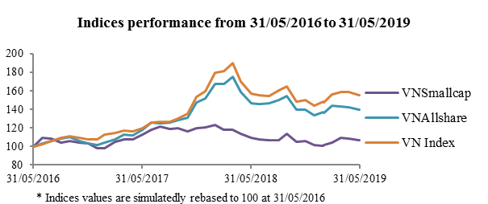 |  |  |  | Index Volatility
 | 3 months | 6 months | 1 year | 3 years | 5 years
VNSmallcap | 4.54% | 6.08% | 10.38% | 19.33% | 27.45%

 |  |  |  | Correlation with VN Index
 | 3 months | 6 months | 1 year | 3 years | 5 years
VNSmallcap | 72.13% | 69.00% | 79.02% | 69.16% | 69.26%

Index Performance
 | Performance (%) |  |  |  |  |  |  |  |  | Annualized Performance (%)
 | 2016 | 2017 | 2018 | 1 month | 3 months | 6 months | 1 year | 3 years | 5 years | 3 years | 5 years
VNSmallcap | 8.94% | 22.54% | -15.81% | -1.41% | 2.92% | 1.33% | -2.01% | 6.89% | 41.05% | 2.25% | 7.12%

Sector Breakdown |  | Top-10 Constituents of Market Capitalization
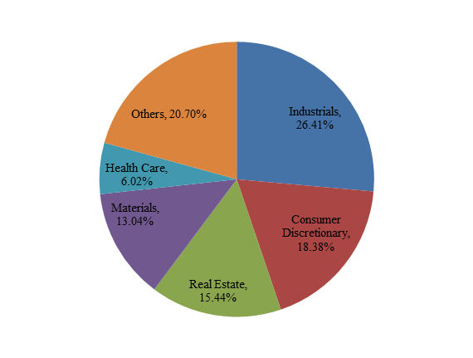 |  | Stock Sector Free-float adjusted market-cap (Billion VND) Weight (%)  1 DBD Health Care 1,835 4.10%  2 DHC Materials 1,030 2.30%  3 DPG Industrials 978 2.18%  4 TCM Consumer Discretionary 945 2.11%  5 FTS Financials 913 2.04%  6 LCG Industrials 904 2.02%  7 TDH Real Estate 889 1.99%  8 STK Consumer Discretionary 865 1.93%  9 VNG Consumer Discretionary 854 1.91%  10 VRC Industrials 835 1.87%  Total 10,047 22.45%  Disclaimer: "VN30", "VNMidcap", "VNSmallCap", “VN100”, “VNAllshare” and "VNAllshare Sector" (collectively called "HOSE-Index") are the registered trademarks and/or service mark solely owned by, and proprietary to the Hochiminh Stock Exchange (HOSE). HOSE-Index can be used to create a range of index-linked products including but not limited to tracker funds, derivatives, etc. Such product creation is subject to approval by HOSE. For more information, please contact via e-mail: index@hsx.vn  All information is provided for information purposes only. Every effort is made to ensure that all information given in this publication is accurate, but no responsibility or liability can be accepted by HOSE nor its directors, officers, employees, partners or licensors for any errors or for any loss from use of this publication or any of the information or data contained herein.
Top-5 Sectors of Market Capitalization
Sector | Number of Companies | Free-float adjusted  market-cap (Billion VND) | Weight  (%)
Industrials | 45 | 11,820 | 26.41%
Consumer Discretionary | 23 | 8,228 | 18.38%
Real Estate | 18 | 6,911 | 15.44%
Materials | 23 | 5,835 | 13.04%
Health Care | 4 | 2,695 | 6.02%

SUMMARY OF HOSE-INDEX’S METHODOLOGY
Selection Criteria:
1. Eligibility:
- Must be listed and traded on HOSE for at least 6 (six) months prior Review Date.
- Must not violate disclosure requirement or subjected to controlled, special control or suspended at least 3 months prior Review Date.
2. Free-float: Companies must have free-float ratio minimum of 10%.
3. Liquidity: Turnover ratio must be at least 0.05%.
Constituents Selection:
1. VNAllshare: Comprises the universe of all constituents that passed Selection Criteria.
2. VN30:
- Eligibility constituents for VN30: Must belong to top-listed accumulated 90% of traded value of VNAllshare.
- 20 largest companies by market-capitalization are chosen. The remaining 10 companies are selected from 21st to 40th ranked in market-capitalization with priority given to current constituent(s) of VN30.
3. VNMidcap:
- Excluding the VN30 constituents, 40 largest companies by market-capitalization from the remaining pool will be chosen.
- 30 Stocks from the 41st to 80th of market-capitalization are select with priority given to current constituent(s) of VNMidcap index.
4. VN100: Comprises all constituents of VN30 and VNMidcap.
5. VNSmallcap: Comprises all constituents of VNAllshare excluding VN100.

GLOBAL INDUSTRY CLASSIFICATION STANDARD (GICS®)
GICS (Global Industry Classification Standard) is the industry classification standard for securities market which developed and managed by MSCI and S&P. Information regarding to GICS classification shall be managed and disclosed by MSCI and S&P.
Securities listing on HOSE shall be classified by MSCI based on GICS standard. Information on listed companies is published on HOSE’s website: www.hsx.vn.
Industrial classification update of constituent stocks shall be made semi-annually on the same date as Review Date.

