VNAllshare Sector Indices |  |  | Data as at: 31 May 2019
VNAllshare Sector Indices is a series of sector index comprised of constituents from VNAllshare which categorized according to the Global Industry Classification Standard (GICS®).
Top-5 Sectors of Performance |  |  | Information
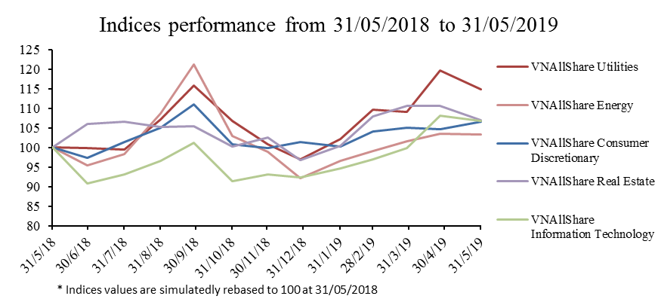 |  |  | Base Date: 25/01/2016  Base Value: 533.49  Availability:  Price indices  Frequency:  Real-time  Capping limit:  Not applied  Calculation Method:  Free-float adjusted market-capitalization weighted index.  Currency: VND
Indices Performance
Sector Indices | 1 month | 3 months | 6 months | 1 year
VNAllShare Energy | -0.31% | 4.22% | 4.48% | 3.25%
VNAllShare Materials | -3.33% | -3.47% | -2.05% | -16.46%
VNAllShare Industrials | 1.17% | -3.05% | -5.60% | -9.67%
VNAllShare Consumer Discretionary | 1.76% | 2.31% | 6.64% | 6.51%
VNAllShare Consumer Staples | 0.34% | -4.72% | 1.92% | 0.29%
VNAllShare Health Care | -1.81% | -0.38% | 14.47% | -0.73%
VNAllShare Financials | -3.04% | -6.62% | -6.23% | -19.55%
VNAllShare Real Estate | -3.31% | -0.84% | 4.35% | 6.99%
VNAllShare Utilities | -4.15% | 4.66% | 13.80% | 14.81%
VNAllShare Information Technology | -1.31% | 9.95% | 14.47% | 6.70%

Indices Characteristics
 | Energy | Materials | Industrials | Consumer Discretionary | Consumer Staples | Health Care | Financials | Real Estate | Utilities | Information Technology
Number of Constituents | 7 | 37 | 64 | 31 | 24 | 6 | 24 | 35 | 12 | 4
Full Market-Capitalization  (Billion VND) | 14,335 | 116,747 | 184,826 | 92,529 | 558,794 | 22,842 | 623,476 | 851,471 | 232,661 | 33,739
Free float adjusted Market-Capitalization (Billion VND) | 6,589 | 62,013 | 100,732 | 54,226 | 199,322 | 7,204 | 223,996 | 276,716 | 21,095 | 25,780
Weight in VNAllshare (%) | 0.67% | 6.33% | 10.28% | 5.54% | 20.35% | 0.74% | 22.87% | 28.25% | 2.15% | 2.63%

Disclaimer:
"VN30", "VNMidcap", "VNSmallCap", “VN100”, “VNAllshare” and "VNAllshare Sector" (collectively called "HOSE-Index") are the registered trademarks and/or service mark solely owned by, and proprietary to the Hochiminh Stock Exchange (HOSE). HOSE-Index can be used to create a range of index-linked products including but not limited to tracker funds, derivatives, etc. Such product creation is subject to approval by HOSE. For more information, please contact via e-mail: index@hsx.vn
All information is provided for information purposes only. Every effort is made to ensure that all information given in this publication is accurate, but no responsibility or liability can be accepted by HOSE nor its directors, officers, employees, partners or licensors for any errors or for any loss from use of this publication or any of the information or data contained herein.

